THESIS SYNOPSIS

Topic -: Tribal Village (Paniya tribe)

Naina Nasrin MC
2019BARC085

Thesis Mentor: Aravind Kumar



1. INTRODUCTION

1.1 PROJECT BACKGROUND
The thesis explores the critical role of tribal craft villages in preserving and promoting indigenous cultures, specifically focusing on the importance of establishing such villages for tribal communities. In the face of globalization and urbanization, traditional crafts face the risk of extinction, leading to a loss of cultural identity. Tribal craft villages serve as vital spaces for the continuation of traditional craftsmanship, contributing to the preservation of cultural heritage and fostering a deeper understanding between tribal communities and the broader society.

1.2 PROJECT BRIEF
The envisioned project is centered around the creation of a Tribal Craft Center in Kerala, with a specific focus on four prominent tribes: Paraya, Paniya, Alar, and Kadar. These tribes are revered for their exceptional skills in bamboo pottery and crafting musical instruments from bamboo. The primary objective of the proposed center is to serve as a focal point for the preservation and promotion of these age-old traditional crafts, which are not only an integral part of the cultural heritage of these tribes but also represent a unique aspect of Kerala's diverse artistic landscape.

Beyond its role in safeguarding these crafts, the center will also function as a gateway to a deeper understanding and appreciation of the forest culture embraced by these communities. Through immersive experiences and interactive exhibits, visitors to the center will have the opportunity to delve into the rich tapestry of traditions, rituals, and lifestyles that are intricately woven into the fabric of tribal life. This immersive approach not only enriches the cultural experience for visitors but also serves as a means of honoring and preserving the invaluable wisdom and knowledge passed down through generations within these tribal communities.

.1.3 RATIONALE
In today's world, the idea of establishing a tribal craft center for multiple tribes in Kerala holds significant relevance across various fronts. It addresses the pressing need to preserve the rich cultural heritage of tribal communities, safeguarding their traditional arts and crafts from being lost amidst globalization. Moreover, given the economic challenges exacerbated by recent global events, such as the pandemic, initiatives promoting tribal crafts offer a pathway to economic revival by empowering m9 | Pagearginalized communities economically. This initiative also plays a pivotal role in Kerala's tourism sector, attracting travelers interested in authentic cultural experiences and contributing to the local economy. Additionally, the emphasis on sustainability in tribal crafts aligns with current environmental conservation efforts, making it a valuable contribution to eco-friendly practices. Furthermore, the craft center serves as a platform for cultural exchange, education, and social inclusion, fostering understanding and appreciation of tribal heritage among diverse audiences. Lastly, in times of crisis, the resilience-building aspect of this initiative becomes even more pertinent, providing communities with avenues for recovery and empowerment.

1.4 AIM
- Preserve Culture: Safeguard traditional arts and crafts of Kerala's tribes.
- Economic Opportunity: Provide a platform for tribal artisans to sell their crafts.
- Skill Training: Offer programs to teach and improve crafting skills.
- Tourism Attraction: Showcase tribal culture to attract tourists.
- Collaboration: Foster learning and exchange among tribal groups.
- Sustainability: Emphasize eco-friendly and fair trade practices.
- Community Support: Address broader socio-economic needs of tribes.

1.5 OBJECTIVES
- To safeguard and promote the traditional art, craft, rituals, and cultural practices of the tribal community
- To provide sustainable livelihoods for tribal artisans, fostering economic independence and reducing dependency on external sources
- .To enhance the overall well-being of the tribal community by creating a supportive and collaborative environment
- .To promote environmentally friendly practices, utilizing local resources and traditional techniques that have minimal ecological impact.
- To involve and empower women within the community by providing them with economic opportunities and a platform for skill development.
To serve as educational centers for both formal and informal learning about indigenous cultures, crafts, and traditions.
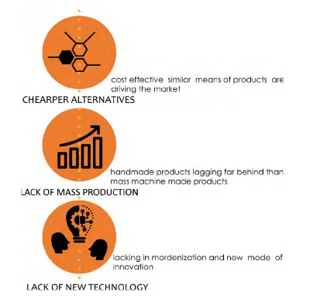
Figure 1 Importance of craft center

1.6 METHODOLOGY

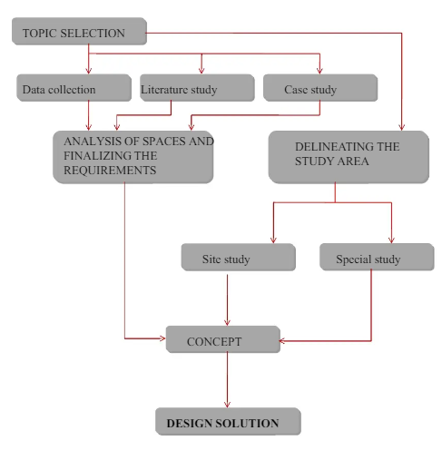
Figure 2 methodology diagram

.1.7 WHY THIS SITE
The site was selected because it has the potential to provide and meet the needs of the community in every means. The site is located close to the forests of Nilambur meaning that the people who depend on the forest products can easily adapt. The site is also comparatively large provided it is in a secluded area, this provides all the resources for the tribal community to thrive. This site has a great potential for tourism. Moreover, this site also has surrounding areas of land which are cultivational lands or open spaces. These allow the community to spread without much limitation.
The site has also been working as a relocated place for tribal communities. After the floods the community relocated nearby to the site. Government had also given permission for the members of the community to settle down and cultivate in parts of the site. Some members of the community have put up tents on site and started living in the site itself. So this site is perfect for these people as they are now used to the site and also shifting them further from their cultivation also reduces the productivity from the community.
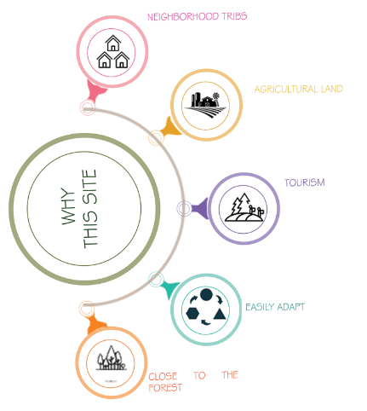
.
Figure 3 site features

